**University Of Engineering And Technology Lahore**

**Project Report**



**IOT Base Air Quality Monitoring System**

**Course Code:**

**CMPE-222L Digital Logic Design**

**Group Members:**

* Talal Muzammal 2021-CE-47
* Kashif Muneer 2021-CE-34
* Mehmood-ul-Haq 2021-CE-35
* Shahzaib Ramzan 2021-CE-41
* Altamash Zaheer 2021-CE-49

**Submit To:**

Engr. Afeef Obaid

**Department Of Computer Engineering UET Lahore**

**Table of Contents**

**Introduction:** 3

**Objectives:** 3

**Abstraction:** 4

**Components:** 5

**Working:** 6

**Block Diagram:** 6

**Flowchart:** 7

**Procedure:** 8

**Code:** 9

**1** **Arduino Code:** 9

**2.Node MCU Code:** 11

**Coding Explanation:** 12

**1. Arduino Explanation:** 12

**2.Node MCU Explanation:** 12

**Displaying Data On Mobile and Laptop:** 13

**Displaying Data on LCD and Serial monitor:** 14

**Final Product:** 15

**Applications:** 15

**Goals:** 15

**References:** 16

# **Introduction:**

An Air Quality Monitoring Station (AQMS) is **a system that measures metrological parameters such as wind speed, wind direction, rainfall, radiation, temperature, barometric pressure and ambient parameters**.

An IoT-based indoor air quality monitoring platform, consisting of an air quality-sensing device called “Smart-Air”

This platform relies on an IoT and a cloud computing technology to monitor indoor air quality in anywhere and anytime. Smart-Air has been developed based on the IoT technology to efficiently monitor the air quality and transmit the data to a web server via LTE in real time.

# **Objectives:**

The device was designed to measure a concentration of aerosol, VOC, CO, CO2, and temperature-humidity to monitor the air quality.

The main objective of these Networks is

* To record the concentration levels of atmospheric pollutants in order to define air quality levels
* Establish action plans if high levels of contamination are detected.
* Locating contamination problem areas and understanding their spacetime changes and to prevent adverse responses by all receptor categories exposed to the atmosphere.
* Complying with atmospheric air protection legislation
* Obtaining the necessary information to define Action Plans as

stipulated by European directives or other international regulations if

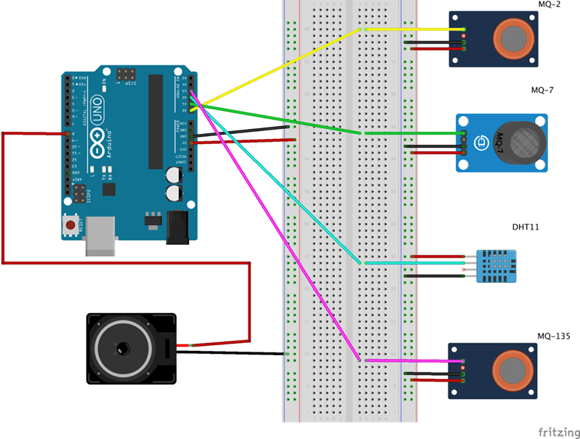alert thresholds are breached. Informing citizens regarding local air quality status.

# **Abstraction:**

Air pollution is both an environmental and a social problem, as it leads to multiple adverse effect on human health, ecosystems and the climate. Air pollution is one of the largest environmental health risks in Europe today. . Around 3 billion people throughout the world use coal and biomass (crop residues, wood, dung, and charcoal) as the primary source of domestic energy. Moreover, humans spend 80–90% of their routine time indoors, so indoor air quality (IAQ) leaves a direct impact on overall health and work efficiency.

Quality of the air in city and urban areas is the most important factor that directly influences the incidence of diseases and decreases the quality of life.

Taking appropriate decisions in a timely period depends on the measurement and analysis of the parameters of the air. The use of multi-parameter air quality monitoring systems makes it possible to do a detailed level analysis of major pollutants and their sources.

We present an approach for cost-effective measurement of relevant environmental parameters, based on a scalable sensor array with integrated amperometric and infrared gas sensors. The device has been tested in the city and the measurement was compared with the output data of the local environmental control authority stations. The preliminary results show that this approach can be used as an economical alternative to the professional grade systems*.*

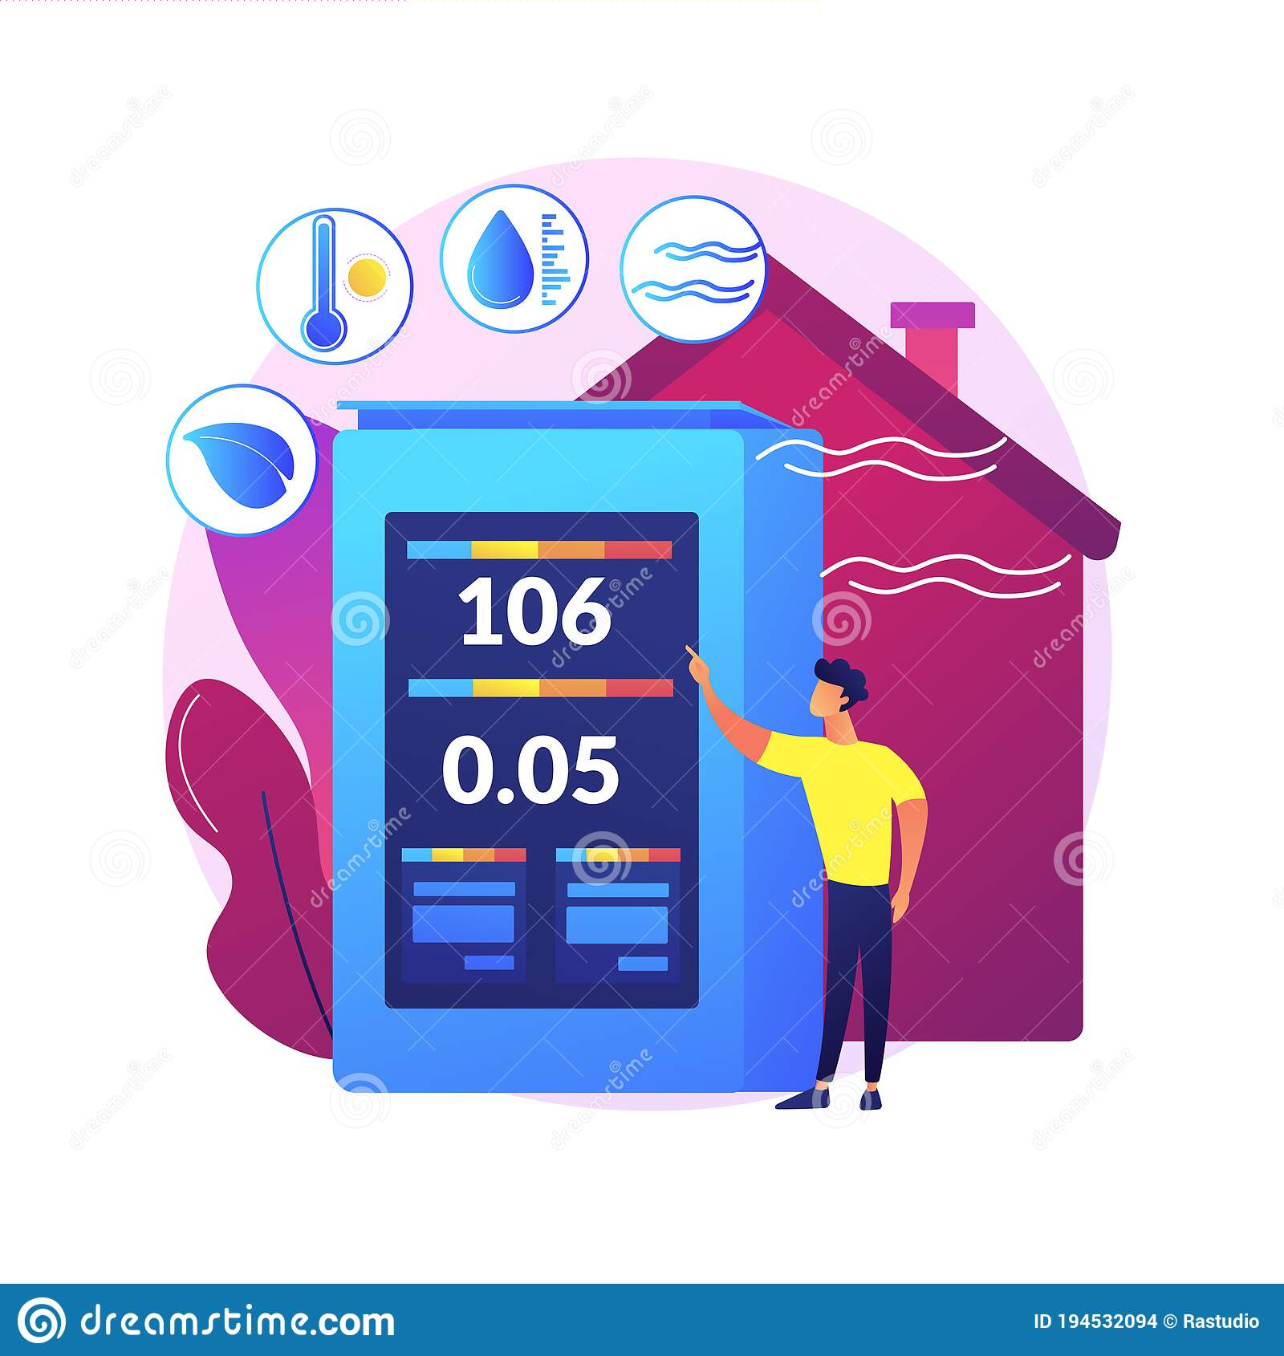

# **Components:**

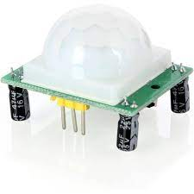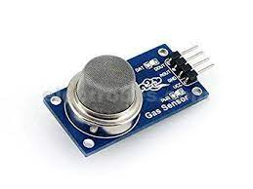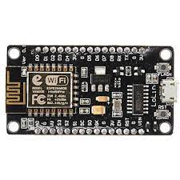This device composed of the following components:

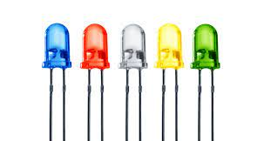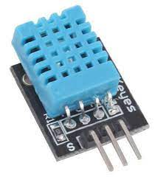1- NodeMCU ESP8266 2- MQ135 Air Sensor 3- PIR Sensor

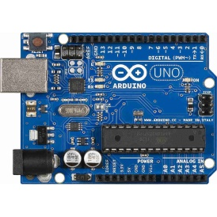

4- DHT11 Sensor 5-Leds 6-Arduino Uno

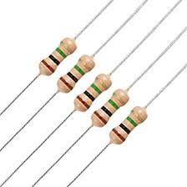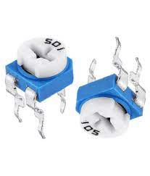

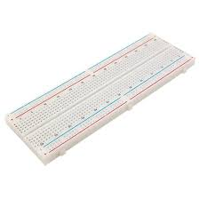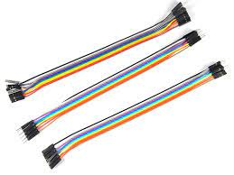7-Resistor 220ohm 8-10K Preset

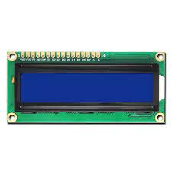9- Jumper Wires 10-Bread Board

11- Crystal LCD (16x2)

# **Working:**

First of all, we will connect the ESP8266 with the Arduino. ESP8266 runs on 3.3V and if you will give it 5V from the Arduino then it won’t work properly and it may get damage. Connect the VCC and the CH_PD to the 3.3V pin of Arduino.

So, we will have to make a voltage divider for it which will convert the 5V into 3.3V. This can be done by connecting three resistors in series like we did in the circuit.

ESP8266 Wi-Fi module gives our projects **access to Wi-Fi or internet**. It is a very cheap device and make your projects very powerful. It can communicate with any microcontroller and it is the most leading devices in the [IOT platform](http://circuitdigest.com/internet-of-things-iot-projects). Then MQ135 sensor starts working with the Arduino.

The MQ135 sensor is a perfect sensor for our Air Quality Monitoring System as it can sense NH3, NOx, alcohol, Benzene, smoke, CO2 and some other gases. When we will connect it to Arduino then it will sense the gases, and we will get the Pollution level in PPM (parts per million). MQ135 gas sensor gives the output in form of voltage levels and we need to convert it into PPM. So for converting the output in PPM. Sensor was giving us value of 90 when there was no gas near it and the safe level of air quality is 250 PPM and it should not exceed 1000 PPM. When it exceeds the limit of 450 PPM, then it starts cause Headaches, sleepiness and many other diseases.

We connect a buzzer to the pin 8 of the Arduino which will start to beep when the condition becomes true. In last, we will [connect LCD with the Arduino](http://circuitdigest.com/microcontroller-projects/arduino-lcd-interfacing-tutorial). The potentiometer is used to control the screen contrast of the LCD. When the value will be less than 1000 PPM, then the LCD and webpage will display “Fresh Air”.  Whenever the value will increase 1000 PPM, then the buzzer will start beeping and the LCD and webpage will display “Poor Air.

# **Block Diagram:**

**Buzzer**

**LED**

**16x2 LCD**

**Microcontroller**

**(Arduino UNO)**

# **Flowchart:**

Define Pins & Direction for LCD, LED, Buzzer & MQ135

Set Threshold for Air Quality,

Start LCD & UART, Read MQ135 (PPM)

Is PPM > Threshold?

Display AQ Level Good,

Turn **OFF** LED & Buzzer

NO

YES

Display AQ Level High,

Turn **ON** LED & Buzzer

# **Procedure:**

1. First of all, Connect the Node MCU ESP8266 module on the breadboard.
2. We use MQ135 Air Monitiring sensor to detect the air of surrounding environment. We connect this module with Node MCU ESP8266 using jumper wires.
3. We use a computer code and try to push it in the ESP8266 using data cable. Once the code has been installed in the this module it will function perfectly and give us output in numeric values.
4. We use Arduino UNO (Arduino boards are able to read inputs - light on a sensor, a finger on a button, or a Twitter message - and turn it into an output - activating a motor, turning on an LED) to take input signals from MQ 135 Sensor and display the output on LCD as well as give output to the buzzer or LED.
5. DH11 Sensor is used to check the Temperature and Humidity of room. We connect this component to Arduino using male to female jumper wires.
6. For additional we can also use PIR Sensor for human dection. This can detect the human resopond in its surrounding and gives us an alert by either buzzer or LED light display. We also connect this module with Arduino UNO.
7. To measure air pressure the BMP380 is a very small, low-power and low-noise 24-bit absolute barometric pressure sensor specifically can be used. It ideally suited for a wide range of altitude tracking applications. This componenet can also connected across Arduinio UNO using Jumper wires.
8. Then we connect LCD to Arduino UNO using male to male Jumper wires.
9. We also connect a buzzer and two LED(red and green) with Arduino using 220 Ohms in series.
10. A potetiometer can be used across LCD to control its display.
11. At last, we connect a battery source with Arduino UNO to give it a power supply.

# **Code:**

## **1** **Arduino Code:**

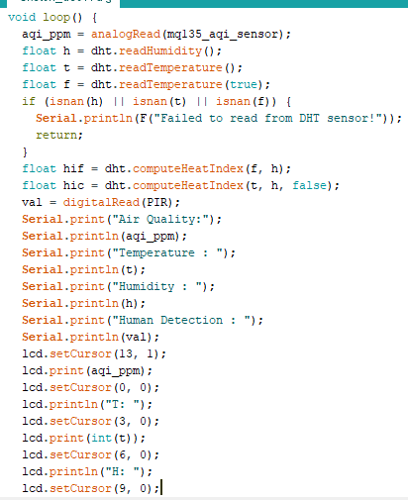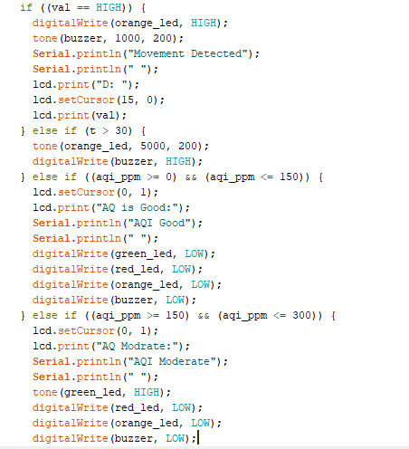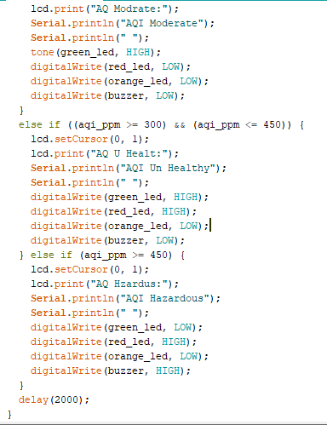

## **2.Node MCU Code:**

# **Coding Explanation:**

## **1. Arduino Explanation:**

In Arduino **#include** is used to define the library of all sensor. The word **const int** is used to define the pins of sensor, Led and buzzer that connect with Arduino. Next, we move to Set Up. In set up we will define the whole sensor as an input or output.

Next, we will move toward Void Loop in which we Call the sensor and store all value in some variable then used in program. Then display all value in **Serial monitor** as well **as crystal led**. Then we will move toward if else condition. In if else condition we define all parameter that when led on or off and as well as Buzzer.

First condition that we define in which we temperate if greater than 30 degrees than buzzer on and Red Led also ON. IN second condition we define PIR sensor if value is high then buzzer and Orang Led is on.

Next, we move toward MQ-135 sensor then split into four conditions. IN first condition we define if the value of air quality sensor is less than 150 ppm then buzzer and all led are off and Lcd display Air quality Very Good. In 2nd condition we define if the quality between 150 and 300 then quality is moderate and green led are show. IN 3rd condition that show if quality between 300 to 450 then both green and red led are on and led display Air Quality are Un-Healthy. The last condition show if the air quality is greater than 450 then Red led on and Led display that air quality is hazardous.

## **2.Node MCU Explanation:**

In Node MCU first of all we create a mobile application and generate the template and define this template into coding and generate the token number from the template.

In next step we give Wi-Fi name and password to node MCU and define all pin that connect with all sensors same as Arduino. Next, we make a Send Senor Function That collect data from sensor and shift to blynk app. For data sending we define the pin. Next, we move toward setup function in which we give the Wi-Fi password and start the Node MCU and the last one step we call blynk and timer function in void loop.

# **Displaying Data On Mobile and Laptop:**

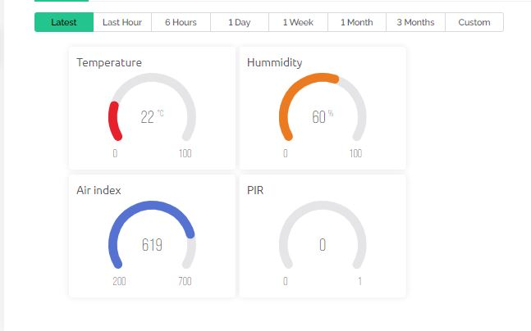Mobile Display

Laptop Display

# **Displaying Data on LCD and Serial monitor:**

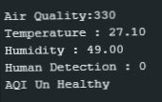

Serial Monitor Display

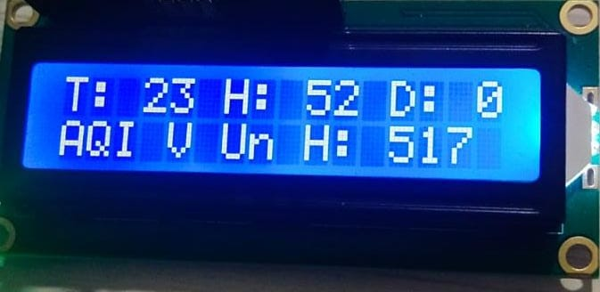

LCD Display

# **Final Product:**

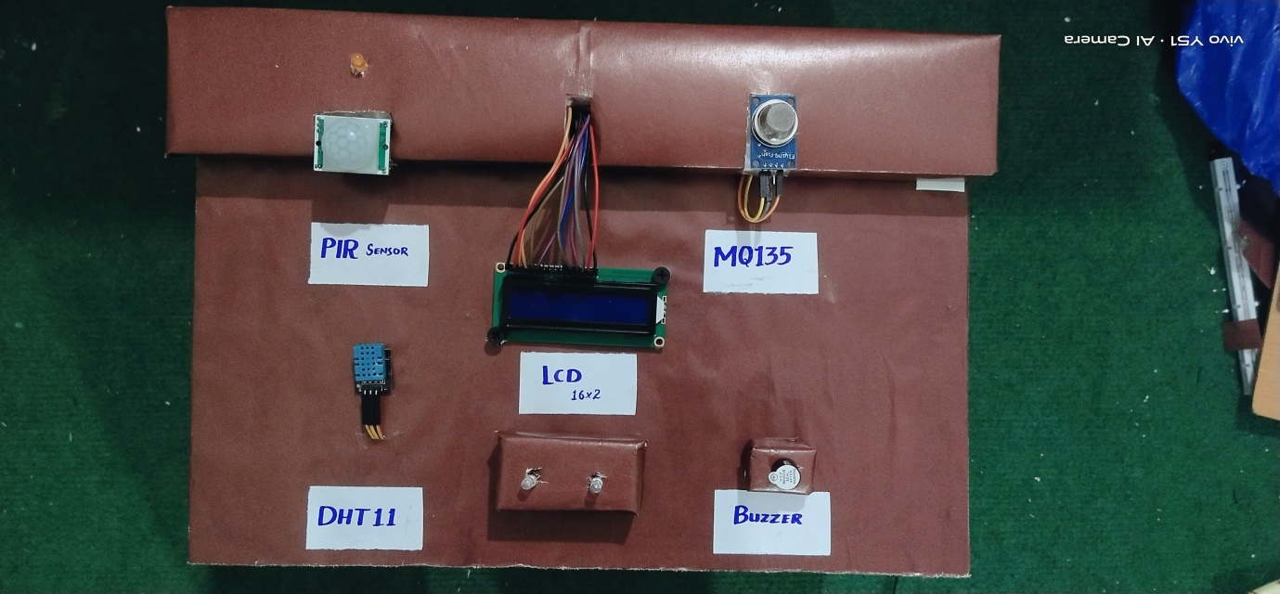

# **Applications:**

1. It is used as Indoor Air Quality Monitoring System
2. It is also used as Outdoor Air Quality Monitoring System
3. It is used for Particulate Matter Monitoring
4. It is used for Gas Detection System.
5. Used for Roadside Monitoring for NO, NO2 and NOx
6. It is used for Research on Ozone and Viruses
7. Used to detect radiation in radioactive areas.
8. Also used in Industrial area to control air pollution.

# **Goals:**

Through this project, we can find out the air purity and temperature and Humidity and human detection and also w can measure a concentration of aerosol, VOC, CO, CO2 to monitor the air quality. And through this project, we can take all these information from anywhere by using IOT.

# **References:**

1-<https://www.hindawi.com/journals/js/2020/8749764/>

2-[https://environmentalsystemsresearch.springeropen.com/articles/10.1186/2193- 2697-1-10](https://environmentalsystemsresearch.springeropen.com/articles/10.1186/2193-%20%20%20%20%20%202697-1-10)

3-<https://www.youtube.com/watch?v=SCXteaUVICw&t=549s>

4-<https://www.youtube.com/watch?v=jo9CeotoyiQ>

5-<https://www.youtube.com/watch?v=r0KPNbiTmaQ>